GRADE 7 ACCELERATED · UNIT 1  Unit 1 Review  Equations and Inequalities — 41 questions | Name_________________________  Date__________________________  Period________________________

HOW TO USE THIS. This review covers every learning target from all ten lessons of Unit 1 — more than the assessment does. Work it in parts. If you miss two or more in a part, that part is where to spend your study time. The reference sheet has everything you need for each part.
PART A. Equivalent Forms of Rational Numbers
Lessons 1 and 2 · 8 questions
1. Write 7/8 as a decimal and as a percent.

2. Write 5/9 as a decimal and as a percent.

3. Write 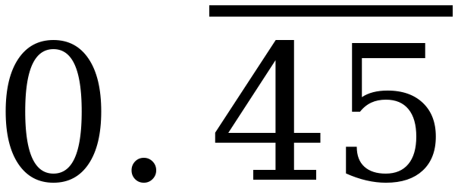 as a fraction in simplest form.

4. Write 0.375 as a fraction in simplest form.

5. Write 128% as a decimal and as a fraction.

6. Order from least to greatest: 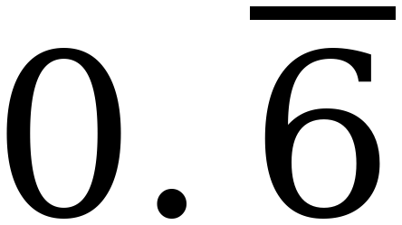, 5/8, 63%, 0.605

7. A calculator shows 0.555555556 when you enter 5 ÷ 9. What is the exact value, and why does the display end in a 6?

8. Which is greater, 4/7 or 0.57 ? Show how you know.

PART B. Solving Two-Step Equations
Lessons 3 and 5 · 9 questions
9. A phone plan costs $32 to start, plus $9 a month.
a. Write an expression for the total cost after m months.

b. The total came to $158. Write and solve an equation for m .

c. Write and solve an inequality for the whole number of months that keeps the total at $200 or less.

d. What does the 32 stand for, and what does the 9 stand for?

10. 5x − 8 = 37

11. −3n + 11 = −16

12. y/4 + 6 = 1

13. 7(x − 3) = 42

14. −2(m + 4.5) = 15

15. ⅔(p − 6) = 8

16. 0.4(t + 25) = 6

17. Solve 3(x + 5) = 27 two ways. Show both.

PART C. Writing and Solving Equations from a Situation
Lessons 4, 6 and 7 · 6 questions
18. A gym charges $45 to join plus $22 a month. A member has paid $221 in all. How many months of membership is that?

19. A restaurant bill was reduced by a $9 coupon and then split evenly among 6 friends. Each friend paid $12.50. What was the bill before the coupon?

20. Five concert tickets were bought and a $3.25 service fee was added to each one. The total was $91.25. What was the price of one ticket before the fee?

21. Elena earns $520 a week plus a 4% commission on her sales. Last week her total earnings were $732. How much did she sell?

22. A coat is marked 35% off. After the discount, Kai uses a $12 coupon and pays $53.00. What was the original price?

23. A tank held 3,600 gallons and is draining at 145 gallons per hour. It now holds 1,570 gallons. How long has it been draining?

PART D. Solutions to Inequalities, and Graphing Them
Lesson 8 · 6 questions
24. Circle every value that is a solution to 2x − 7 ≥ 5. −2 0 5.9 6 6.1 12

25. Solve and graph: 4x − 3 ≥ 1

26. Solve and graph: −2x + 3 > 13

27. Solve and graph: x/2 − 1 > 1

28. Solve and graph: 7 − x ≥ 16

29. Explain how you know that 0.5 is not a solution to 3x + 1 > 2.5.

PART E. Inequalities with the Distributive Property
Lesson 9 · 5 questions
30. Solve and graph: 4(x + 1) ≤ 12

31. Solve and graph: −3(x − 1) < 9

32. Solve and graph: ⅕(x + 6) < 3

33. Solve −2(3x − 5) ≥ 22 two ways. Show both.

34. Sam solved −4(x + 2) > 8. He distributed the −4 and reversed the symbol, then divided by −4 and reversed again. What went wrong, and what is the correct solution?

PART F. Inequalities in Real-World Situations
Lesson 10 · 5 questions
35. Write an inequality: a ride requires riders to be at least 48 inches tall. Use h for a rider's height in inches.

36. A field trip costs $180 plus $14 for each student. The budget is $630. How many students can go? Justify your answer.

37. Marisol needs at least $185 for a bike. She has $40 and will save the same amount each week for 8 weeks. What is the least she can save each week?

38. A store sells ¾ of the items on a shelf, then brings out 60 more. The store keeps at least 200 items on the shelf. How many items were on the shelf to begin with?

39. A phone plan costs at most $50 a month. It charges $28 plus $0.11 for each gigabyte of data. How many whole gigabytes can be used?

PART G. Looking Ahead: the Unknown on Both Sides
Later this year · 2 questions
40. Solve 5(n − 2) = 3n + 8.

41. Plan A costs $60 to join plus $8 an hour. Plan B costs $20 to join plus $12 an hour. At how many hours do the two plans cost the same?

